ANOVA:

One Way ANOVA

Q1: To assess the significance of possible variation in performance in a certain test between the convent schools of a city, a common test was given to a number of students taken at a random from the 5th class of the 3 schools concerned. The result is given as follows:

|  |  |  |
| --- | --- | --- |
| A | B | C |
| 9 | 13 | 14 |
| 11 | 12 | 13 |
| 13 | 10 | 17 |
| 9 | 15 | 7 |
| 8 | 5 | 9 |

Make the Analysis of Variance of the given data. (Null Hypo: No Significance Variation in the schools).

Solution:

Null Hypothesis = No variation between schools

Alt. Hypothesis = There is variation between schools.

|  |  |  |  |  |
| --- | --- | --- | --- | --- |
| Source of Variation | Sum of Square | Degrees of freedom | Mean Square | F |
| Between the Sample | SSC | (c-1) | MSC = SSC/df1 | F = MSC/MSE |
| Within the sample | SSE | (n-c) | MSE = SSE/df2 |

|  |  |  |
| --- | --- | --- |
| A | B | C |
| 9 | 13 | 14 |
| 11 | 12 | 13 |
| 13 | 10 | 17 |
| 9 | 15 | 7 |
| 8 | 5 | 9 |

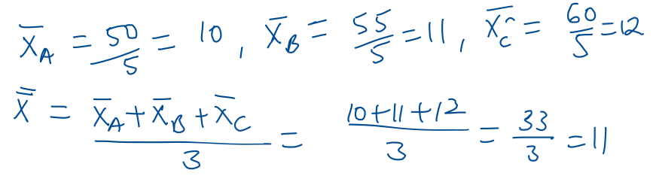

SSC Calculation:

|  |  |  |  |  |  |
| --- | --- | --- | --- | --- | --- |
|  |  |  |  |  |  |
|  |  |  |  |  |  |
|  |  |  |  |  |  |
|  |  |  |  |  |  |
|  |  |  |  |  |  |
|  |  |  |  |  |  |
|  |  |  |  |  |  |



SSE Calculation:

|  |  |  |  |  |  |
| --- | --- | --- | --- | --- | --- |
|  |  |  |  |  |  |
|  |  |  |  |  |  |
|  |  |  |  |  |  |
|  |  |  |  |  |  |
|  |  |  |  |  |  |
|  |  |  |  |  |  |
|  |  |  |  |  |  |



|  |  |  |  |  |
| --- | --- | --- | --- | --- |
| Source of Variation | Sum of Square | Degrees of freedom | Mean Square | F |
| Between the Sample | SSC = 10 | df = (c-1)  = 3-1  = 2 | MSC = SSC/df  = 10/2 = 5 | F = MSC/MSE  = 5/11.5  = 0.435 |
| Within the sample | SSE = 138 | df = (n-c)  = 15 – 3  = 12 | MSE = SSE/df  = 138/12  = 11.5 |



Q2: 2-Way ANOVA

The following data represents the number of Units of Tablet production (in thousands) per day by five different technicians by using 4 different machines.

1. Tell whether the mean productivity of the different machines are same?
2. Test whether the 5 technicians differ w.r.t. the mean productivity?

|  |  |  |  |  |
| --- | --- | --- | --- | --- |
| Machines  ……  Technicians | A | B | C | D |
| P | 54 | 48 | 57 | 46 |
| Q | 56 | 50 | 62 | 53 |
| R | 44 | 46 | 54 | 42 |
| S | 53 | 48 | 56 | 44 |
| T | 48 | 52 | 59 | 48 |

Solution:

|  |  |  |  |  |
| --- | --- | --- | --- | --- |
| Source of Variance | Sum of Squares | Degree of Freedom | Mean sum of squares | F |
| Between the columns | SSC | df = c-1 | MSC= SSC/(c-1) | MSC/MSE |
| Between the rows | SSR | df = r-1 | MSR = SSR/(r-1) | MSR/MSE |
| Residual Errors | SSE | df = (c-1)(r-1) | MSE =  SSE/(c-1)(r-1) |  |
| Total Sum of Square | SST | df = n-1 |  |  |

Step1: Calculation of grand total and correction factor.

Mid Value = (42+62)/2 = 52.

However, Let’s assume mid value for easy calculation as 50. (You can take 51 or 52 also.)



|  |  |  |  |  |  |
| --- | --- | --- | --- | --- | --- |
|  | A | B | C | D | Row Total |
| P | 54 – 50 = 4 | 48-50 = -2 | 57-50 =7 | 46-50 =-4 | 5 |
| Q | 56-50=6 | 50-50 =0 | 62-50 =12 | 53-50 =3 | 21 |
| R | 44-50=-6 | 46-50 =-4 | 54-50 =4 | 42-50 =-8 | -14 |
| S | 53-50=3 | 48-50 =-2 | 56-50 =6 | 44-50 =-6 | 1 |
| T | 48-50 = -2 | 52-50 =2 | 59-50 =9 | 48-50 =-2 | 7 |
| Col Total | 5 | -6 | 38 | -17 | Grand Total = 20 |

Correction Factor = T2/N



= (Grand Total)2/N

=(20)2/20 Note: N = Total observations = 5 * 4 = 20

=20

Step2 : Calculation of SSC



SSC =

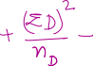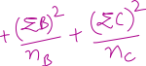

Step 3: Calculation of SSR

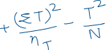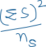

SSR =

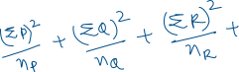

Step 4: Calculation of SST

SST = Sum of square of all observations residuals – correction factor



SST =



|  |  |  |  |  |
| --- | --- | --- | --- | --- |
| Source of Variance | Sum of Squares | Degree of Freedom | Mean sum of squares | F |
| Between the columns | SSC = 288.8 | df = c-1  = 4-1  =3 | MSC= SSC/(c-1)  =288.8/3  =96.27 | MSC/MSE  = 96.27/9.76  =9.86 |
| Between the rows | SSR = 158 | df = r-1  =5-1  =4 | MSR = SSR/(r-1)  = 158/4  =39.5 | MSR/MSE  = 39.5/9.76  =4.05 |
| Residual Errors | SSE = SST – (SSC+SSR)  = 564 – 288.8 – 158  = 117.2 | df = (c-1)(r-1)  =(4-1)(5-1)  =12 | MSE =  SSE/(c-1)(r-1)  = 117.2/12  = 9.76 |  |
| Total Sum of Square | SST = 564 | df = n-1  = 20-1 = 19 |  |  |

Let’s see the Tabulated value of F:

For Between the columns, df1 =12, df2=3. (F)tab = 3.49

(F)tab < (F)calc; Hence, Null is rejected. i.e. there is significant variation between the columns.

For Between the rows, df1 = 12, df2=4, (F)tab = 3.26

(F)tab < (F)calc; Hence, Null is rejected. i.e. there is significant variation between the rows.

--------------------------------------------------------------------------------------------------------------------------

Reference:

F-Table for alpha 0.05

